NENEKARA

TE REO APP

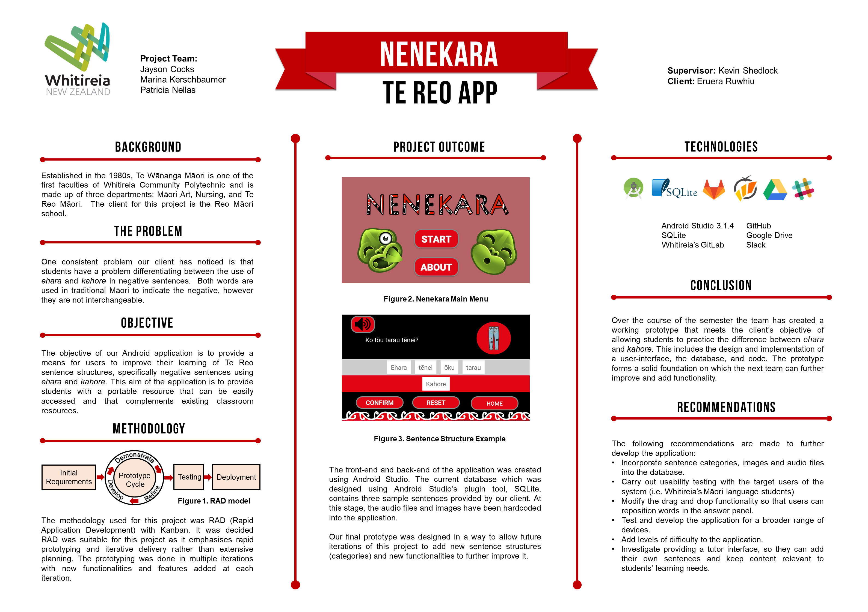

# Background

Established in the 1980s, Te Wānanga Māori is one of the first faculties of Whitireia Community Polytechnic and is made up of three departments: Māori Art, Nursing, and Te Reo Māori.  The client for this project is the Reo Māori school.

In order to achieve proficiency in both formal and informal situations, the school takes the approach of teaching students traditional Māori.  Once students have become proficient in using more traditional language they are then in a position to learn more colloquial expressions and judge when it is appropriate to use them.

One consistent problem tutors have noticed, is that students have a problem differentiating between the use of *ehara* and *kahore* in negative sentences.  Both words are used in traditional Māori to indicate the negative, however they are not interchangeable. Further contributing to the confusion between the two words is the fact that *ehara* can also be used as colloquial expression meaning “*For sure!”*.

In addition to classroom textbooks and handouts, students have several resources available to assist them with independent learning. These include CDs, an online dictionary for looking up individual words and the hard copy Dictionary of Māori Language (H. W. Williams) which provides more detailed information around vocabulary and its use. These resources are all valuable in their own right, however they lack interactivity and customisability.

# Objective

The objective of our Android application is to provide a means for users to improve their learning of Te Reo sentence structures, specifically negative sentences using ehara and kahore.

This aim of the application is to provide students with a portable resource that can be easily accessed and that complements existing classroom resources.

# Project Scope

1. The purpose of the project was to come up with a working prototype of an Android application that enables students to practise differentiating between *ehara* and *kahore.* While the focus for this first prototype is exclusively on sentences containing these two words, the application has been designed so that other sentence structures can be added, in order to extend the usefulness and relevance of the application in future.
2. The project used RAD development methodology and was split into five, two‑week iterations that progressively built on the previous iterations.
3. Each iteration was made up of:
   * The development of an interface.
   * The development of a database in SQLite that stores the sentence structures.
   * The development of the program in Android Studio, tying together the database and interface and providing the application’s functionality.
   * Black box testing of the components that had been developed in each iteration.
   * At the end of each iteration the Client was presented with the product for feedback. In the initial iterations this was a simple interface and as the project went through each iteration further functionality was added.
4. The current prototype-iteration of the application is designed to work on an LG Nexus 5 running Android 6.0.1 phone.
5. A user manual and system documentation were created to support the application by providing the client and future developers with background and reference material about the project.

# Methodology

The methodology used for this project was RAD (Rapid Application Development) with Kanban. It was decided RAD was suitable for this project as it emphasises rapid prototyping and iterative delivery rather than extensive planning. The prototyping was done in multiple iterations with new functionalities and features added at each iteration.

The life cycle of RAD has four stages:

***1.    Initial Requirements***

The project team met with the client and came to a rough agreement on the business needs, application requirements, and project scope before prototyping began.

***2.     User Design/Prototyping***

This stage allowed the creation of prototypes the client’s initial requirements. A prototype was then presented to the client to collect user feedback. Any suggested changes that emerged from this feedback were considered, and if necessary, added to the requirements.

***3.     Construction***

Coding, testing, and integration took place in this stage. This, along with the user design stage, were repeated as often as necessary as alterations and refinements were added based on the client’s feedback.

***4.     Implementation***

When all the system requirements were met and the user feedback is entirely positive, project team will finalise and launch the product. This phase also includes testing and user training.

To help with work transparency and task planning, the Kanban methodology was used alongside RAD. Kanban’s Agile process framework fitted in well with RAD’s flexibility to changes and continuous delivery approach.  This helped give structure to the methodology used throughout the development of the project.

# Project Artefact

The application provides the users with a simple front-end interface which displays the question (in both text and audio form), an image, and the jumbled answer separated into individual components.

The front-end and back-end of the application was created using Android Studio. The current database which was designed using Android Studio’s plugin tool, SQLite, contains three sample sentences provided by our client. At this stage, the audio files and images have been hardcoded into the application.

Our final prototype was designed in a way to allow future iterations of this project to add new sentence structures (categories) or new functionalities to further improve it.

# Technology

The project was developed in Java using Android Studio as the development environment. Java was the natural choice of language for the project as all team members had previous experience using it for course work.

Android Studio's platform is fully supported by Google and incorporates tools such as debuggers and emulators. It also offers several other advantages, such as the ability to drag-and-drop user interface components, preview layouts on multiple screen configurations and extensive support documentation and development community.

SQLite, an open-source, lightweight, and standalone database was used as the backend database for the application. SQLite supports embedded relational database features and Android Studio has a built-in SQLite database implementation.

Because SQLite is embedded within the code, this presented an issue of not being able to view and manage the data easily. DB Browser for SQLite was used to overcome this. DB Browser for SQLite is a visual, open source tool designed to manage database files compatible with SQLite.

Whitireia's GitLab repository was used throughout the project in conjunction with GitHub. This enabled the team to work collaboratively and access the files of the project through a single source. It also allowed for easier documentation, testing, and kept track of the application's versioning.

The hardware used to develop the application were HP EliteBook 8560p laptops provided by Whitireia which were already installed with Android Studio. The team was provided with two LG Nexus 5 smartphone devices which were used to test the application.

Google drive was used to store the proposal, system documentation, presentation, poster, and application design files. This allowed for easy sharing and editing of these documents.

# Conclusion

Over the course of the semester the team has created a working prototype that meets the client’s objective of allowing students to practice the difference between ehara and kahore. This includes the design and implementation of a user-interface, database and code. The prototype forms a solid foundation on which the next team can further improve and add functionality.

# Recommendations

The following recommendations are made to further develop the application:

* Incorporate sentence categories, images and audio files into the database.
* Carry out usability testing with the target users of the system (i.e. Whitireia’s Māori language students)
* Modify the drag and drop functionality so that users can reposition words in the answer panel.
* Test and develop the application for a broader range of devices.
* Add levels of difficulty to the application.
* Investigate providing a tutor interface, so they can add their own sentences and keep content relevant to students’ learning needs.